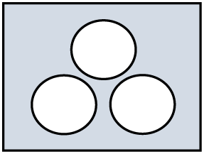
Redesigned Curriculum Planning Framework Adapted from the work of SD #43
Coquitlam
Looking Forward …
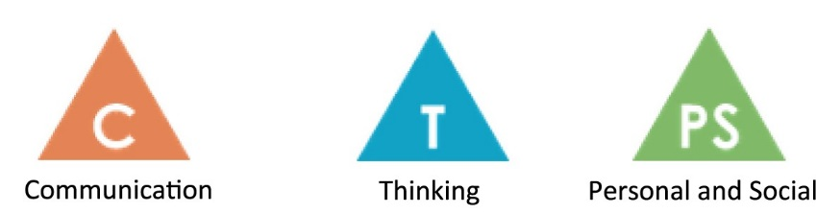
What core competencies and shared values for learning together will students be developing and practicing over time?
How will growth be documented by teachers and by students?
Understand | Big Ideas:
 | Essential questions:
Do | Curricular Competencies:
Know | Content:

